A mathematical relation is a set of ordered pairs.
- Each ordered pair contains an independent variable called the input and a dependent variable called the response or output
- The independent variable is often denoted x and the dependent variable y

A relation can be expressed in several ways:
- A list of coordinates or a table of values
- A graph
- An equation

Examples:
R1: {(2, 4) (3, 5) (-1, 5) (2, 5)}
R2: { (5,2) (0,1) (5, 6) }
R3: { (2,3) (8,3) (6,3) }
R4: { (1,3) (2,1) (0,0) }

R5
R6
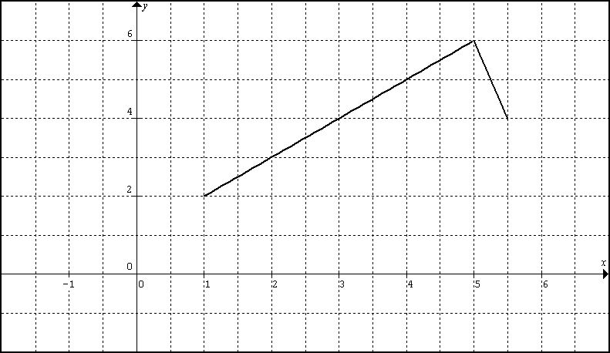
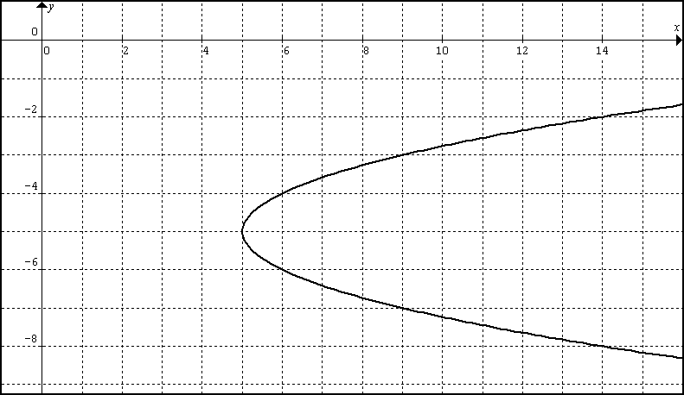

R7
R8
R7

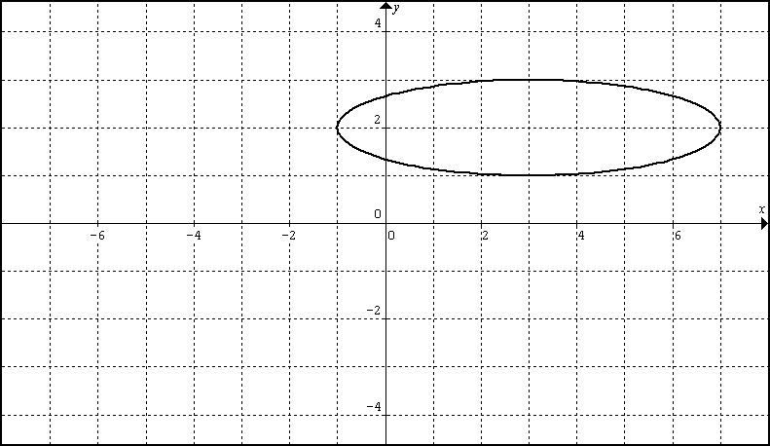
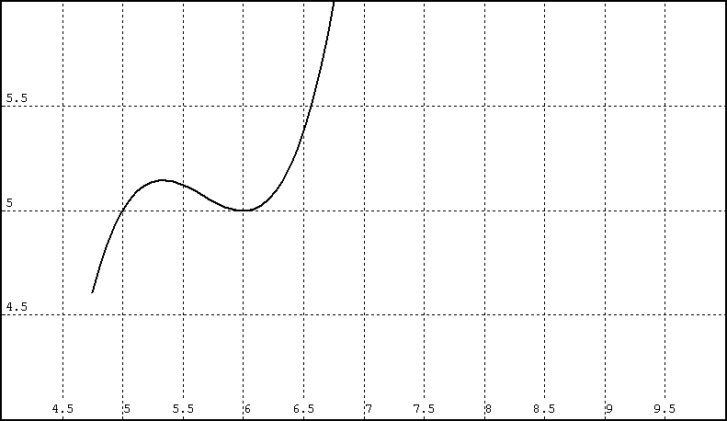

R9: $2x+y=1$ R10: $x^{2}+y^{2}=9$ R11: $y=\frac{2x}{x−3}$ R12: $x+y^{2}=\text{16}$

The domain of a relation is a set of all the independent variable’s values (all the x-values)
It is preferred to write the x values from smallest to largest

The range of a relation is a set of all the dependent variable’s values (all the y-values)
It is preferred to write the y values from smallest to largest

Practice:
Find the domain and range for each relation R1 – R8 above.
Find the domain (only ) for R9 and R11.
How might one go about finding the domain for R10 and R12

A function is a special relation where each value of the independent variable is paired with exactly one value of the dependent variable. (Each input x is paired with exactly one output y)

To determine whether a relation is a function:
- Use Mapping
- Use the Vertical Line Test
- The straight definition

Practice:
Determine which relations R1 – R8 are functions.
How might one go about deciding whether R9 – R12 are functions?

Functions like relations are expressed in several ways:
- A list of coordinates or a table of values
Domain: List all the x-values (once) Range: List all the y values (once)

- A Graph
Domain: Express all x-values from the minimum to maximum x.
Note any holes, gaps, asymptotes, etc
Range: Express all y-values from the minimum to maximum y.
Note any holes, gaps, asymptotes, etc.

- An Equation
Domain: Express all x-values from the minimum to maximum x.
It is often the case to state that x can be any real number.
In other cases we say x can be any real number with exceptions.
The exceptions are the values of x that make the denominator zero.
(we make sure to state these exceptions)
Range: Express all y- value from the minimum to maximum y.
It is often the case to say y can be any real number.

